 | Agenda | 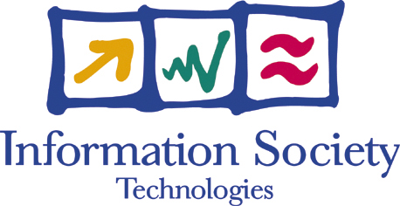

EC Adonis Project Workshop

11 March 2004, Moscow

Russian Academy of Sciences  32a, Leninsky Prospect, Moscow  Contact persons for logistics:  Mr Evgeny Babayan  tel+7(095)938-1861, e.babayan@ras.ru  Ms Olga Kanaeva  Tel: +7(095) 938-1851, kanaeva@vmail.ras.ru | 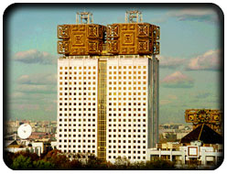

10:00 – 10:20 - Welcome and foreword, by V. Fortov (RAS)
10:20 – 10:40 – “Framework Programme 6 - IST call 3” by V. Kopanas, the European Commission
10:40 – 11:15 - Presentation of the NIS SW Outsourcing Market, by S. Makedonsky or O. Filppula (Market-Visio)
11:15 – 11:45 - Adonis Project overview and Adonis Business Model, by R. Vardapetian (EuroTex)

11:45-12:00 – Coffee break

12:00 – 12:30 – Conception of NewAdonis Association of the NIS SW Companies, by A. Rakhimov (Bacup IT)
12:30 – 13:00 – Sharing the experience. 4 years of Fort Ross urge for closer IT cooperation between EU and the NIS, by V. Makarov (Fort-Ross)
13:00 – 14:00 Lunch break

14:00 – 15:00 - Round table 1: Strengthening EU-NIS Cooperation in Software Development. Moderators S. Makedonsky and O. Filppula (Market-Visio)
15:00 – 16:00 - Round table 2: Overcoming Main Risks of SW Outsourcing. Moderator K. Svensson (TeliaSonera)
16:00 – 16:15 - Foreword by R. Vardapetian

